Name Class Date
Your teacher may watch to see if you can:
- measure volumes accurately.
Aim
The aim of this investigation is to find the order of reactivity of the metals calcium, magnesium and zinc with hydrochloric acid, by measuring the volumes of gas produced over a set time interval.
Prediction
- a What do you think this experiment will show about the reactivity of these metals?

b Explain why you think this is.

Apparatus
- magnesium ribbon ● stopper and delivery tube  - calcium granules ● 50 cm³ measuring cylinder  - zinc granules ● plastic basin  - dilute hydrochloric acid ● stop clock  - emery paper ● spatula  - 250 cm³ conical flask |  Care needed when using dilute acids.  Wear eye protection at all times.
Method
- Set up the apparatus as shown opposite using clean glassware.  - Add 25 cm³ of dilute hydrochloric acid to the conical flask.  - Add a small piece of magnesium ribbon to the flask. Immediately replace the stopper and start the stop clock.  - Measure and record the volume of gas formed after 20 seconds.  - Clean all apparatus and repeat steps A to D one more time.  - Repeat the experiment with a spatula of zinc granules. Add your teacher's results for calcium to the table. | 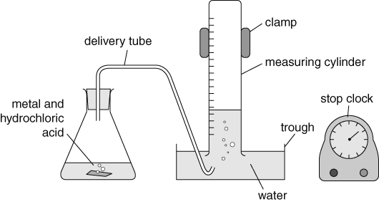

Recording your results
 | Metal
 | Calcium |  | Magnesium |  | Zinc
 | 1st try | 2nd try | 1st try | 2nd try | 1st try | 2nd try
Volume of gas produced in 20 seconds (cm³)
Mean volume of gas produced in 20 seconds (cm³)
Considering your results/conclusions
- Calculate the mean volume of gas produced for each metal, to fill in the rest of the table.
- a What is the order of reactivity of these metals with hydrochloric acid? (Most reactive first.)

b Explain your answer to part a using the evidence from your experiment.

Evaluation
- Does your results table contain any anomalous results? Explain your answer.

- Are your results repeatable? Explain your answer.

- Look at the results of other groups in your class. Are your results reproducible? Explain your answer.

- What is meant by accurate data?

- a Explain what you did when carrying out the experiment to make sure your results were accurate.

b Suggest one way that the accuracy of the results could have been improved.

I can...
- describe the reactions of metals and acids
- identify data that is, or is not, reliable, repeatable or reproducible
- explain how to improve the quality of data collected during an investigation.

