Name Class Date
The metals listed below have similar physical properties. They are all solid, shiny and flexible and are good electrical and heat conductors. They also share some chemical properties, but some react quickly while others react very slowly.
aluminium copper iron magnesium potassium sodium silver
Answer the following questions about these properties of metals.
- The two metals that react very quickly with water are sodium and
- The two products formed by the reaction between sodium and water are:
and gas
- When copper is heated in oxygen the compound formed is
- A metal that burns brightly but does not react quickly with water is
- Look at the diagram opposite, which shows three metals reacting with acids. Which metals from the list above could be reacting in each tube? | 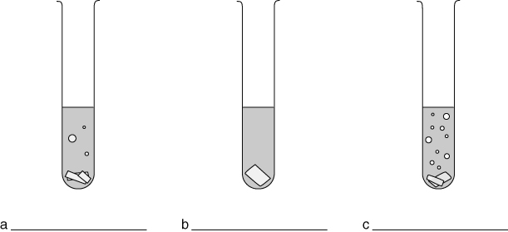
- The salt formed by sodium and hydrochloric acid would be sodium
- The acid used to make sodium sulfate would be
- We would not add sodium to any acid in the laboratory because it is too
- The metal just above zinc in the reactivity series that is used to make wall panels is

- Metals that corrode quickly are unsuitable for building because they react with

I can...
- describe the reactions of oxygen, water and acids with metals
- name the products formed when metals react with oxygen, water and acids
- relate the uses of elements to their properties.

