
- An experiment was set up to see if attaching other metals to iron affected how quickly it rusted.
The results of the experiment are shown below.
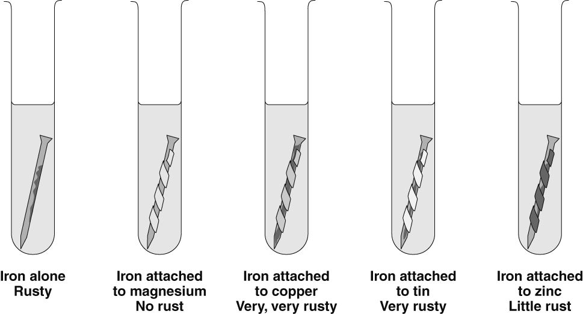
- Name the two metals that speed up rusting when they are attached to iron.
- Name the two metals that slow down rusting when they are attached to iron.
- Explain how this effect on rusting is connected to the reactivity series.
- Name two other metals that could be used to protect iron from rusting.
- The metals that protect iron from rusting do so by reacting more quickly with water than the iron does. Their reaction prevents the iron from reacting and so stops it rusting. This method of protection is sometimes called sacrificial protection and it keeps working as long as the other metal is present.
- For each of the two metals that were shown to slow down rusting, write word equations for their reactions with water.
- Why do you think this is called sacrificial protection?
- Use the results of the experiment to draw out a reactivity series for the elements in the experiment.
- Do some research to check your order. Make any change that you need to make to your reactivity series, clearly showing the changes that you have mad.
- Do some research to identify a metal that would speed up or slow down the rusting of iron in a similar way to each one of the four metals in question 1.
I can...
- place metals in an order of reactivity
- write word equations for reactions of metals and water.

