Name Class Date
- The metals calcium, lithium, potassium and sodium have to be kept dry because they react quickly with water. Some metals are stored under oil to keep out water and air.  Complete these sentences about what happens when these metals get wet. | 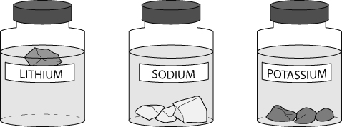
- When lithium is added to water it appears to because
gas is produced.
- The solution formed turns universal indicator purple, showing that it is .
- Potassium is the reactive of the metals, and it bursts into
when dropped into water.
- is the only one of the metals that sinks in water and reacts at the bottom of the test tube.
- The heat produced when sodium reacts with water makes it into a ball.
- All four metals react to produce and an solution.
- Water (formula H₂O) is a compound of two gases, hydrogen and oxygen.
- What is the test for hydrogen gas?

- What type of reaction needs oxygen gas?

- The chemical properties of metals can affect how they are used. Explain the following statements about metals and their uses.
- Sodium and lithium are two of the lowest density metals and float easily on water. However, sodium and lithium are never used to make ships.

- Copper is far more expensive than iron, yet water pipes are made from copper and not iron.

I can...
- describe the reactions of metals with water
- describe the gas test for hydrogen
- relate the uses of different elements to their chemical properties.

