
Cut out the drawing cards and the description cards about different metals reacting with water.
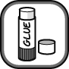
Complete the descriptions and match up and arrange the descriptions with the correct drawings.

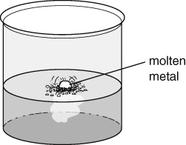 | 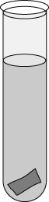 | 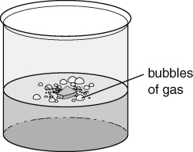
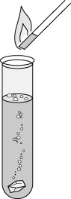 | 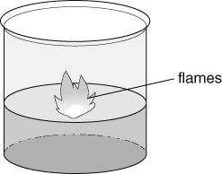 | 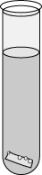
Description cards
Magnesium reacts very slowly with water. Only a few small bubbles of  gas is produced when left for a few days. | Copper metal does not react with cold water. Even if left in water for days, it remains  . | Calcium reacts quickly with water forming lots of bubbles of gas. The gas .  when a burning splint is brought near.
Potassium bursts into flames and fizzes about while  on the surface of the water. | Sodium reacts quickly, producing hydrogen gas.  The heat of the reaction  the sodium, which forms a small ball of molten metal on the surface of the water. | Lithium .  on the surface of the water. The gas produced pushes the metal about the surface as it disappears during the reaction.
I can...
- describe the reactions of metals with water
- describe the test for hydrogen.

