- Read the following passage and then answer the questions.
Iron can be protected from rust by painting or using another coating to keep out air and water. The protection only works if the coating doesn’t get scratched or broken. Sometimes a different method of protection has to be used.
Sacrificial protection involves attaching iron to a more reactive metal like magnesium or zinc.  For example, blocks of zinc are attached to the hulls of some ships to reduce rusting.  The protection works as the more reactive metal corrodes more quickly than the iron. In the example above, the zinc corrodes instead of the iron. We say that it has ‘sacrificed itself’ to protect the iron and so this is called ‘sacrificial protection’. | 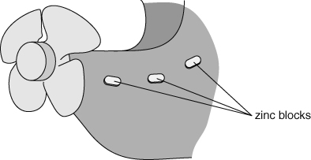
Note that the opposite happens when a less reactive metal is attached to iron – the iron rusts faster than normal.
- How does painting prevent rusting?
- Why do painting or plastic coatings not protect iron for ever?
- Name two metals that are used in sacrificial protection.
- Why does the zinc attached to the hulls of ships have to be replaced regularly?
- Problems can arise as soon as two metals are joined together. One metal will always corrode faster than usual while the other will corrode more slowly.
Answer the following questions about metals in contact with each other.
- Copper roof plates should be attached using screws made of copper. Explain what would happen if these plates were attached using iron screws.
- Food tins are often made of iron coated in tin. The coating is thin, so it is easily scratched and broken. Explain why old food tins seem to rust more quickly than other iron objects.
- Galvanising involves coating iron with zinc metal. The galvanised iron has many uses in industry and building. Explain the advantage of a zinc coating over coatings of other metals like tin.
I can...
- use ideas about reactivity to explain how sacrificial metals can protect iron from rusting.

