- Four different metals were added to separate flasks of water, as shown opposite.  The volume of gas given off in 10 seconds was measured and the experiment was carried out twice for each metal.  The results are shown below the diagram.  - Calculate the mean volume of gas produced by each metal.  - Draw a bar chart of the mean volume of gas produced by these metals in 10 seconds.  - Which gas is produced in these reactions?  - List the metals in order, from the one  that gives off the most hydrogen down  to the one that gives off the least.  - Explain the order of metals in your answer to part d. | 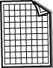  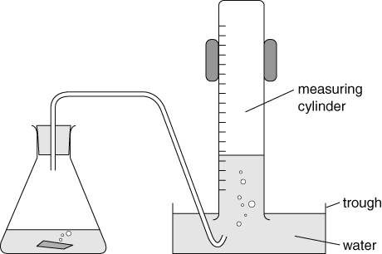
  Metal | Volume of gas (cm³)
  Metal | 1st try | 2nd try | Mean
  calcium | 24 | 22
  lithium | 30 | 36
  magnesium | 0 | 0
  sodium | 42 | 44
- Describe how you would carry out a test for hydrogen.
- Suggest which metal could be being described in each case below.
- Soft, silvery metal that melts when it reacts with water.
- Brown coloured metal that doesn’t react with water.
- Solid metal that sinks in water and reacts with it quickly.
- Copy and complete these word equations for the reactions of metals with water.
- sodium + → sodium hydroxide + .
- + → magnesium hydroxide + hydrogen
- Copy and complete the following general equation for the reaction of metals with water.
metal + water → metal + .
I can...
- describe the reactions of metals and place metals in an order of reactivity
- model simple reactions of metals and water using word equations.

