Name Class Date
- Some metals cannot be used in buildings as they react too quickly with water.
Look at the diagram and complete the sentences.  - The metal is called  - The gas formed is called  - A better metal for water pipes would be | 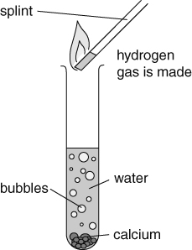
- Some metals are more reactive with water than others.
- Draw lines to match up the sentence halves to describe some reactions of metals with water.
Magnesium … |  | melts into a ball and fizzes a lot on the surface.
Potassium … |  | floats on the surface producing bubbles of gas.
Lithium … |  | burst into flames.
Sodium … |  | reacts very slowly producing a few bubbles.
- Write 1–4 in the blank boxes to show the reactivity of the metals. 1 is the most reactive.
- Complete this word equation for the reaction of lithium and water.
lithium + water → + .
- Hydrogen is formed by the reaction of metals with water.
Tick (✓) the correct box to show the properties of hydrogen.
 | True | False
Hydrogen is a solid at room temperature.
Hydrogen is a liquid at room temperature.
Hydrogen is a gas at room temperature.
Hydrogen puts out a burning splint.
Hydrogen burns with a ‘squeaky pop’ when lit.
I can...
- describe the reactions of metals with water
- describe the gas test for hydrogen.

