Name Class Date
- State the name of the reaction that occurs when a metal corrodes in air.

- Name all three reactants involved in rusting.
, and
- Objects made from iron are often coated to prevent rusting.
- Name three different coatings that are used to protect iron structures.
- How does coating the iron prevent rusting?
- Complete the word equation below.
zinc + oxygen → ,
- A group of students set up the experiment shown opposite. They left it for a few days to see where rusting would occur.  Rusting only occurred in test tube 1. | 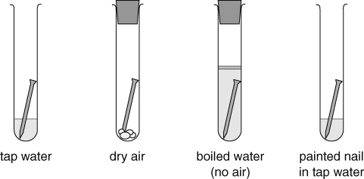
- Explain why rusting does not occur in test tubes 2, 3 and 4.
Test tube 2

Test tube 3

Test tube 4

I can...
- explain what happens during corrosion and rusting and how it can be prevented
- write word equations.

