
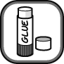
- The diagrams show a series of experiments that have been set up to investigate rusting. Colour in the diagrams to show where rusting will occur.
Cut out the diagrams and statements and then arrange them to make a poster on corrosion.

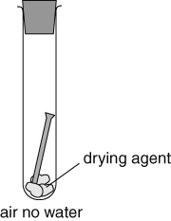 | 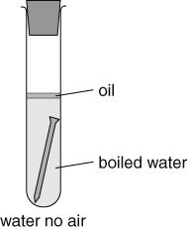 | 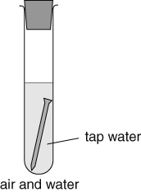
Rusting is the corrosion  of . | Rusting needs and  to be present. | Painting iron can prevent  .
Painting forms a .  to keep out air and water. | Corrosion is the  of a metal. | Tanks left in the desert do not rust quickly as there is very little .
- Complete these word equations about oxidation reactions.
Reactants
Ti  titanium | + | O₂  oxygen |  | → | TiO₂  . .
Cr  chromium | + | O₂ |  | → | CrO₂  .
I can...
- explain what happens during rusting and how it can be prevented
- write word equations
- identify reactants and products in symbol equations.

