Name Class Date
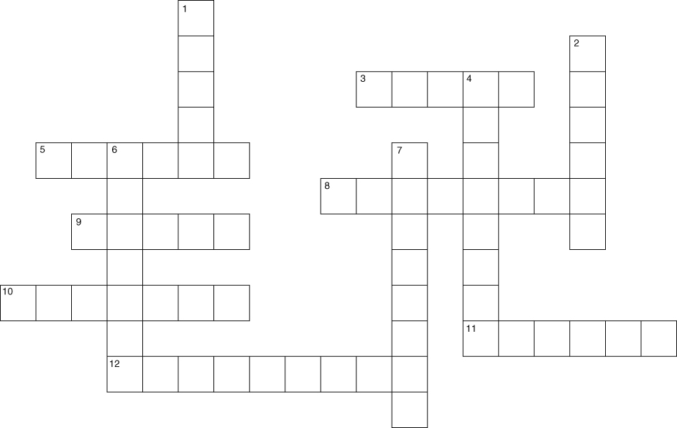
Across  3 In time, titanium will form a coating on titanium roofing sheets. (5)  5 and 1 down Product of corrosion of copper in air. (6) & (5)  8 Copper is better than iron for water pipes as it is less . (8)  9 Must be present along with air for iron to rust. (5)  10 The corrosion of iron. (7)  11 Metals used in building usually react  in air. (6)  12 Type of reaction that forms an oxide coating on zinc. (9) | Down  1 See 5 across.  2 Element needed for metals to corrode. (6)  4 What rust does to iron structures like bridges. (8)  6 This coating is used to protect iron dish drainers. (7)  7 Simple method of preventing rusting. (8)
I can...
- state what happens during corrosion and rusting
- explain how metals can be protected from corrosion
- relate the uses of different elements to their chemical properties.

