Name Class Date
Your teacher may watch to see if you can:
- follow instructions to remain safe.
Introduction
Iron objects can rust quickly if left outside, but what substances need to be present for iron to rust?
Aim
To find out whether water, oxygen or both water and oxygen need to be present for iron to rust.
Prediction
- What do you think will need to be present for iron to rust?

Apparatus
- 3 test tubes ● drying agent  - 3 iron nails ● spatula  - 3 stoppers ● emery paper  - 250 cm³ beaker ● tripod stand  - test-tube rack ● Bunsen burner and gauze  - oil ● heatproof mat |  Wear safety glasses during the experiment.  Take care when boiling water and when handling boiled water.
Method
- Put about 60 to 70 cm³ of water into the 250 cm³ beaker.  - Set up the beaker on the tripod stand with the Bunsen burner in a safe place.  - Heat the water and boil for 3 to 4 minutes.  Water that has been boiled for some time will contain no air (oxygen).  - Set up three clean, dry test tubes in a  test-tube rack. | 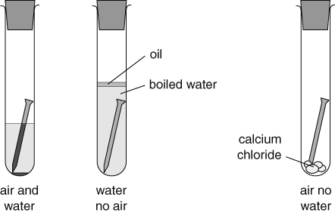
- Clean three iron nails by rubbing them with emery paper. Carefully add one nail to each test tube.
- Add tap water to cover the nail in the first test tube and stopper the tube.
- Add a few granules of drying agent to the second test tube and stopper the tube. The drying agent removes water from the air.
- Carefully add the boiled water to cover the nail in the third test tube. Add a few drops of oil to form a layer on the water and insert a stopper the tube.
- Leave the test tubes for a few days to observe the changes that occur.
Recording your results
- After a few days look at the test tubes and describe any changes you see.

Considering your results/conclusions
- What do the results tell you?

Evaluation
- How did you know if the iron had rusted?

- Why was a layer of oil put onto the test tube of boiled water?

Check your results and conclusions with your teacher.
- Were any of your results different from what your teacher expected?

- Suggest a possible reason why any of your results might have been wrong.

I can...
- explain how metals can be protected from corrosion
- make and record observations accurately and draw conclusions.

