Name Class Date
- Match up the sentence beginnings and endings to make correct sentences about metals and non-metals.
- Corrosion is when a metal ... |  | ... oxygen and water are required.
- Zinc oxide forms during ... |  | ... corrosion of iron.
- For rusting to occur ... |  | ... by painting the metal.
- Rusting is the ... |  | ... reacts with oxygen.
- Rusting can be prevented ... |  | ... the corrosion of zinc.
- Complete the following descriptions of corrosion and chemical reactions.
- When titanium reacts with oxygen, titanium is formed.
- The reaction between a metal’s surface and oxygen is called .
- Iron metal is not used for water pipes because it would .
- The reaction opposite is an example of a quick reaction.  Describe a reaction that happens very slowly. | 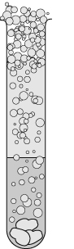
- Complete the following word equation which represents the corrosion of zinc.
zinc + → zinc oxide
I can...
- describe what happens during corrosion and rusting
- explain how metals can be protected from corrosion.

