Name Class Date
- The diagram shows the heart pumping.
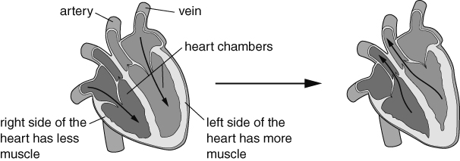
The diagram is going to be used in a textbook to explain how the heart pumps. Write a short paragraph to explain what is happening. In your paragraph include all the labels from the diagram.
- The drawings show some different cells found in blood.
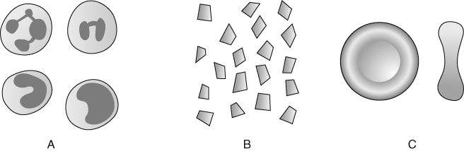
a Which of these cells carry oxygen – A, B or C?
b Where are these cells made?
c What substance does this cell contain that makes it adapted to this function? Choose one word from the box.
antibody globohaemin haemoglobin oxytocin plasma
d Describe the function of one other cell in the blood.
e What is the name of the fluid that surrounds the cells in the blood?
f Describe one function of this fluid.
- Look at the drawings of blood vessels.
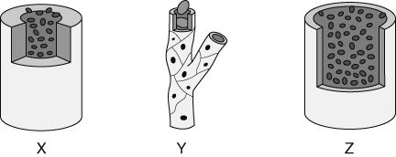
- Which drawing (X, Y or Z) shows a capillary? Explain your reasoning.
- What are the names of the other two types of blood vessels and what are their functions?
I can…
- describe the role of muscles in the heart
- describe the functions of blood vessels
- describe the functions of the different parts of blood and where they are made.

