Formulae from structures
The formula of a compound made up of molecules tells us the number of atoms of each element in its molecules. If the compound is made up of a giant lattice then the formula tells us the ratio of the atoms of the elements in the lattice.
- Write down the formulae of the compounds with the following structures. | 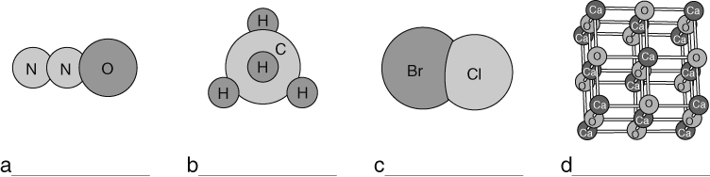
Formulae from valencies
The joins between atoms in a compound are called bonds. The atoms of each element can all form a certain number of bonds. The number of bonds must match up when they join together. So, magnesium atoms form two bonds and chlorine atoms form one bond, and so two chlorine atoms are needed for each magnesium atom in magnesium chloride (MgCl₂).
The valency of an element is the number of bonds that its atoms can form. We can use valencies to work out formulae. The valency is often linked to an element’s group in the periodic table:
Valency 1  (Groups 1 and 7) | Valency 2  (Groups 2 and 6) | Valency 3  (Groups 3 and 5) | Valency 4  (Group 4)
potassium – K  chlorine – Cl  bromine – Br | magnesium – Mg  calcium – Ca  oxygen – O | aluminium – Al  nitrogen – N  phosphorus – P | carbon – C  silicon – Si
The valencies of some elements can change and so the valency is shown by a roman numeral in its name. For example, the valency of iron in iron(III) oxide is 3 but in iron(II) chloride its valency
is 2.
We can use valencies to work out formulae. A method of doing this, called the ‘cross-over method’, is described below.
- Write the symbols of the elements.  - Write the valencies of the elements underneath the symbols.  - Cancel down or simplify the valencies if possible.  - Cross-over the numbers and tidy up to give the formula. | 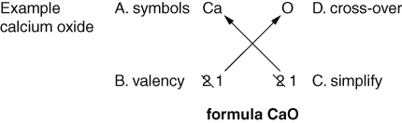
- Work out the formulae of the following compounds using the valencies in the table above.
- potassium nitride | - magnesium chloride | - aluminium oxide
- nitrogen chloride | - aluminium phosphide | - calcium oxide
- iron(II) bromide | - zinc(II) nitride | - cobalt(III) oxide
- Look at the formulae below. Work out the valencies of the named elements.
- nickel in NiO | - iron in FeCl₃ | - cobalt in CoO
I can...
- work out the formulae of simple two-element compounds using valencies.

