A model can represent how atoms join to one another. The joins are called bonds. The atoms of each element can all form a certain number of bonds.  The number of bonds must match up when they  join together.  The number of bonds formed by an element’s atoms  is called its valency. | 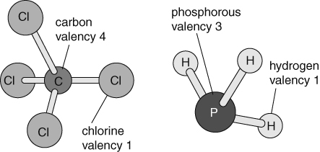
The valency of many elements is linked to their groups in the periodic table.
- Copy and complete the table below showing the valency of the elements and three examples of elements in each group.
Group | 1 | 2 | 3 | 4 | 5 | 6 | 7
Valency | 1 | 2 |  | 4 | 3 | 2
Examples |  |  |  |  |  |  | F/Cl/Br
The formulae of compounds can be worked out on paper, using the ‘cross-over method’. It is described below.
- Write the symbols of the elements.  - Write the valencies of the elements underneath the symbols.  - Cancel down or simplify the valencies if possible.  - Cross-over the numbers and tidy up to give the formula. |  | 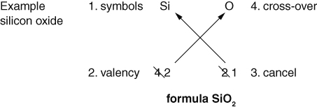
- Use the cross-over method to work out the formulae of the following compounds.
- sodium phosphide | - calcium oxide |  | - magnesium carbide
- aluminium nitride | - beryllium bromide |  | - boron sulfide
- calcium chloride | - boron fluoride |  | - silicon oxide
The valencies of transition metals, those in the central block of the periodic table, can vary. The valency is usually indicated by a roman numeral in the name:
1 = (I); 2 = (II); 3 = (III); 4 = (IV); 5 = (V); 6 = (VI); etc.
For example, in copper(II) chloride the copper has a valency of 2.
- Use the cross-over method to work out the formulae of the following compounds.
- iron(III) fluoride | - silver(I) oxide |  | - cobalt(II) oxide
- copper(I) nitride | - copper(II) bromide |  | - iron(III) sulfide
I can...
- use valencies to work out the formulae of simple two-element compounds including transition metals.

