The table below shows some properties of different metals.
Metal | Strength  (the higher the number the better) | Density (g/cm³) | Hardness  (1 is softest and 10 is hardest) | Energy conduction by heating  (higher numbers mean better heat conductor) | Energy conduction by electricity  (higher numbers mean better electrical conductor) | Speed of reaction with oxygen  (the more ‘‘, the faster the reaction) | Relative cost of metals  (the more ‘£’ the higher the cost)
iron | 82 | 7.9 | 4.0 | 80.4 | 17 |  | £
aluminium | 26 | 2.7 | 2.5 | 237.0 | 62 |  | £££
copper | 48 | 8.9 | 3.0 | 401.0 | 100 |  | ££££
platinum | 61 | 21.5 | 4.2 | 71.6 | 16 |  | ££££££££££
osmium | 222 | 22.5 | 7.0 | 87.6 | 18 |  | ££££££££££
- Which of the columns in the table describes something that is not a property of metals?
- Write word equations for the reactions of aluminium and copper with oxygen.
- Use the information in the table to answer these questions. Explain each of your answers.
- Which one property makes copper useful for electrical wiring?
- Which physical property makes aluminium better than iron for window frames and doors?
- Apart from cost, which physical property of aluminium makes it a worse choice than iron for windows and doors?
- Why would copper be a good choice for making house radiators?
- Why are most house radiators made from iron rather than copper?
- Answer these questions using the table above and the following information about catalytic converters.
Catalytic converters are found in car exhausts. They are used to reduce pollution. The converters contain metals such as platinum and osmium. These metals act as catalysts for the reactions that change harmful gases in exhaust fumes into harmless gases.  - What is a catalyst and what does the catalyst do in car exhaust systems?  - Which physical property is most different for osmium and platinum compared to the other metals in the table? | 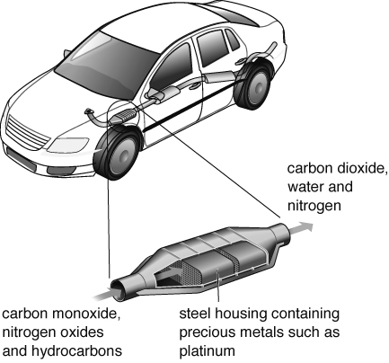
I can...
- explain the properties and uses of metals
- write word equations for the reactions of metals and non-metals
- describe what a catalyst is and some uses of catalysts.

