

Cut out the following statements and drawings about the properties and uses of metals. Arrange them under the headings given in the first line.

Use in building | Metals used | Important property

roofing |  | water pipes |  | building frames
windows frames |  | electrical wiring |  | central heating radiators
steel | iron |  | copper |  | lead
aluminium | copper |  | titanium |  | steel
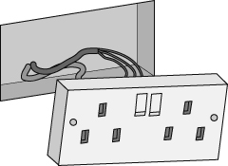 |  | 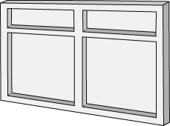 |  | 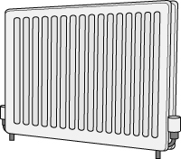
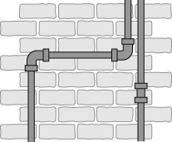 |  | 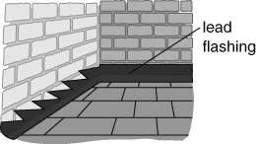 |  | 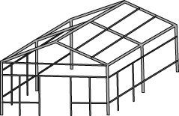
The metal is easily shaped  and does not with water. |  | The metal is so  it can be bent into different shapes. |  | The metal is strong and  .(low density).
The metal is a good conductor  of . |  | The metal is and  can hold up heavy structures. |  | The metal is a good conductor  of .
I can...
- describe some common properties and uses of metals
- link the properties of metals with their uses.

