Your teacher may watch to see if you can:
- follow instructions and carry out experiments safely.
Name Class Date
Zinc reacts with sulfuric acid to produce hydrogen gas. Certain metals, like copper, can act as catalysts for this reaction.
The rate of reaction can be compared by measuring the time taken to produce a certain volume of hydrogen gas.
Aim
To investigate how the speed of the reaction between zinc and sulfuric acid is changed by mixing small pieces of different metals with the zinc.
Prediction
- Describe what you expect to happen when the different metals are mixed with the zinc. Explain your reasoning for your predictions.

Apparatus
- zinc granules ● spatula  - copper turnings ● 4 test tubes  - pieces of nickel ● test-tube rack  - dilute sulfuric acid ● small basin  - 10 cm³ measuring cylinder ● stopper and delivery tube  - 20 cm³ measuring cylinder ● stop clock  - eye protection |  Take care when handling dilute acids.  Wear eye protection at all times.
Method
- Set up the apparatus so that the gas produced in the reaction is collected in the measuring cylinder, as shown opposite.  - Add a piece of zinc to the test tube.  - Add 1 cm³ of dilute sulfuric acid to the test tube. Immediately insert the stopper and start the stop clock.  - Note the time taken to collect 10 cm³ of gas in the measuring cylinder.  - Repeat steps A to D using exactly the same conditions, but add two or three pieces of copper to the zinc before adding the acid.  - Repeat steps A to D using exactly the same conditions, but add two or three pieces of nickel to the zinc before adding the acid. | 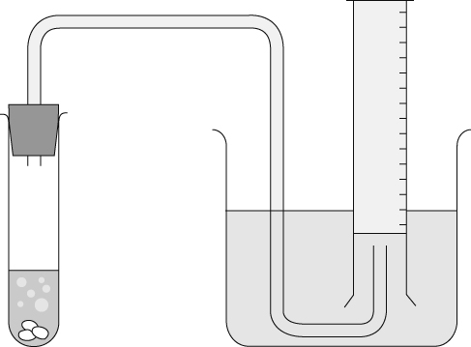

Recording your results
Record your results in the table below.
 | Zinc alone | Zinc + copper | Zinc + nickel
Time to collect 10 cm³ of gas (s)
- Do any of the metals look different after the reaction has taken place?

Considering your results/conclusions
- Which experiment produces the hydrogen gas most quickly and which produces it most slowly?

- Do copper and/or nickel act as a catalyst for the reaction between zinc and sulfuric acid?
Explain your answer.

Evaluation
- a Describe the variables that have to be controlled during this investigation.

b Why is it necessary to control these variables?

- What could you do in order to be more certain about your conclusions?

I can...
- carry out experiments safely
- make and record observations accurately and draw conclusions.

