
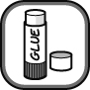
Only noble gas elements exist as single atoms. In most substances, the atoms are held together forming two main types of structure, which are described below.
Molecular structures: Groups of atoms which are held together. The molecules of a substance are all the same size. |  |     Lattice structures: Many billions of atoms held together in a regular arrangement. The lattice structure has no set size.
The names and structures of different elements and compounds are shown below.
Colour in the atoms of different elements in according to the colour chart below.
sodium = grey | magnesium = light blue | copper = brown | carbon = black
oxygen = red | hydrogen = white | sulfur = yellow | chlorine = green
Use secondary sources to find the melting point and boiling point for each of the substances.
Cut out each structure and organise them in two columns under the headings and descriptions of ‘molecular structure’ and ‘lattice structures’.
- Describe the difference in melting points and boiling points between the two types of structure.
Molecular structures | Lattice structures
sodium chloride  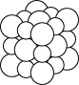  melting point = °C  boiling point = °C | sulfur  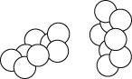  melting point = °C  boiling point = °C
water  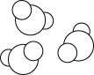  melting point = °C  boiling point = °C | magnesium oxide  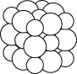  melting point = °C  boiling point = °C
carbon dioxide  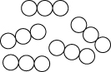  melting point = °C  boiling point = °C | methane (carbon hydride)  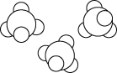  melting point = °C  boiling point = °C
carbon (diamond)  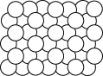  melting point = °C  boiling point = °C | copper metal  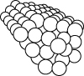  melting point = °C  boiling point = °C
I can...
- state that atoms can be joined up to make molecules or giant lattice structures
- describe the difference between molecules and giant lattice structures.

