The noble gases are a special group of elements that are very unreactive. They generally exist as single atoms. Since these elements don’t naturally react with other substances, the noble gases were one of the last groups of elements to be discovered.  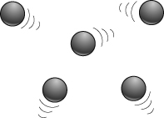
  Noble gas | M.pt. (°C) | Diameter of atom (nm)
  He | –272 | 0.031
  Ne | –249 | 0.038
  Ar | –189 | 0.071
  Kr | –157 | 0.088
  Xe | –112 | 0.108
Helium was first discovered in the Sun in 1869. It wasn’t until 1905, when argon was isolated, that scientists realised there was a whole group of elements missing from the periodic table.
The noble gases are all very unreactive elements. However, scientists eventually found they could make compounds of some of the noble gases.  The first two compounds made were xenon hexafluoride and xenon difluoride (XeF₂), both of which have molecular structures, like carbon dioxide.  Noble gases don’t form any lattice structures like sodium chloride. | 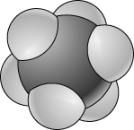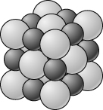  xenon hexafluoride sodium chloride
Some compounds of krypton have also been made. However, compounds of argon and neon are rare and, at present, there are no reported compounds of helium.
Where are the noble gases found in the periodic table?
Why were the noble gases so difficult to identify?
Describe the trends in melting point and atom diameter down the noble gas group.
The atomic sizes are given in ‘nm’. What does ‘nm’ stand for?
Estimate the melting point and atom diameter for radon, the sixth member of the noble gas group.
What is the formula of xenon hexafluoride?
- Draw diagrams of a molecule of xenon difluoride.
- Describe the trend in reactivity of the noble gases down the group.
- Explain the trend you have described in 8.
- Light bulbs that contain argon work by heating a fine wire of the element tungsten until it glows white. Why is using argon gas better than using a light bulb filled with air?
- The first airships used hydrogen gas, which is the lowest density (lightest) gas of all. Suggest a reason why helium is a better choice than hydrogen for airships, even though its density is not as low as that of hydrogen. (Hint: Think about this in terms of safety.)
Sodium chloride is a giant lattice structure. Xenon hexafluoride is a molecular structure.
Explain the different between the two structures.

I can...
- describe and identify trends in physical and chemical properties as you go down a group
- describe the difference between molecules and giant lattice structures.

