Name Class Date
Complete the following word equations using the words in the box below.
carbon hydrogen lithium oxygen sodium sodium oxide water
+ → lithium oxide
sodium + oxygen → .
+ oxygen → carbon dioxide
+ → sodium hydroxide + .
- Complete the crossword using the clues below.
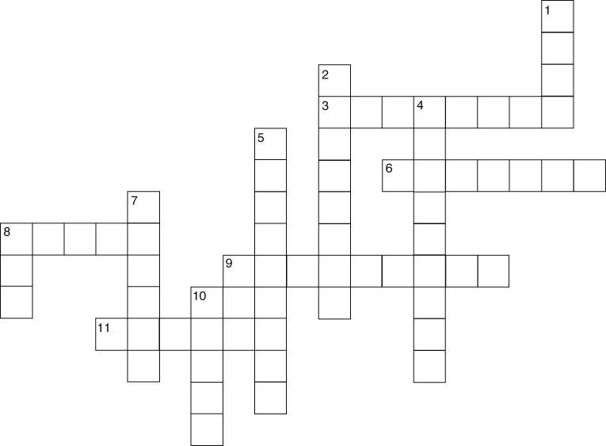
Across  3 Gas produced when lithium and sodium react with water (8)  6 An element that reacts like potassium (7)  8 Sodium forms this if left out in the air (5)  9 The order of reactivity is lithium then, sodium, then, (9)  11 and 7 down The name given to the group 1 elements of the periodic table (6) and (6) | Down  1 What reactive metals do when heated in air (4)  2 and 4 down The (8)  (9) of elements in the same group are similar. (8) and (9)  5 Sodium is an alkali (9)  7 see 11 across  8 Lithium and sodium are stored in this (3)  10 All alkali metals react with this liquid (5)

I can...
- describe the reactions of metals and non-metals with oxygen
- describe the reactions of metals with water
- use the reactions of some alkali metals to predict the reactions of other alkali metals.

