Name Class Date
Add the missing words to complete the descriptions of the reactions of the first three
alkali metals with water.
Alkali metal: Lithium  Symbol:  Group 1  How stored: Under oil  Reaction with water: Floats and fizzes forming a gas  Word equation for reaction with water:  lithium + water → lithium hydroxide + hydrogen |  | 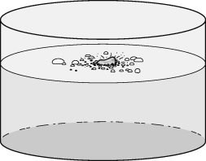
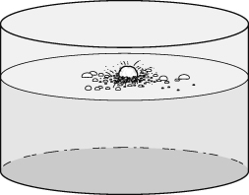 | Alkali metal:  Symbol: Na  Group:  How stored:  Reaction with water: Melts into a ball and fizzes forming a  Word equation for reaction with water:  sodium + water → +
Alkali metal:  Symbol: K  Group 1  How stored: Under oil  Reaction with water: Catches and forms a gas  Word equation for reaction with water:  potassium + .→ potassium hydroxide + |  | 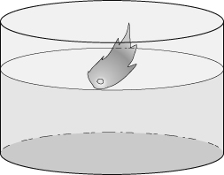
- Draw lines to match up the correct starts and ends of these sentences about elements reacting with oxygen.
The reaction of zinc with oxygen ... |  | ... is sulfur dioxide.
When elements react with oxygen ... |  | ... it is reacting with oxygen.
When an element burns in air ... |  | ... produces zinc oxide.
The product of sulfur and oxygen ... |  | ... compounds called oxides form.
I can...
- describe the reactions of some elements with oxygen and water
- use information about the reactions of an element to predict reactions of other similar elements.

