Your teacher may watch to see if you can:
- work safely.
Introduction
Many elements form oxides easily. Some burn in air to form oxides, others will only form oxides when heated in oxygen. Some of these oxides form acidic solutions and others form alkaline solutions when added to water.
Aim
To look for a trend in the pH of oxides of elements going across the periodic table.
Prediction
Do you think the oxides of elements will get more or less acidic going across the periodic table? Explain your reasoning.
Method
Apparatus  - 0.2 mol dm^{–3} potassium hydroxide  - 0.2 mol dm^{–3} sodium hydroxide  - calcium hydroxide  - carbon dioxide solution  - 0.2 mol dm^{–3} nitric acid  - 0.1 mol dm^{–3} phosphoric acid  - universal indicator liquid  - 7 test tubes  - test tube rack |  |  Wear eye protection. Take care not to spill or splash any chemicals.
- Add about 1 cm depth of one of the oxides in water to a test tube.  - Add a few drops of universal indicator to the test tube.  - Observe the colour of the indicator.  - Use the colour chart to find the pH of solution.  - Record the colour and pH of the solution of this oxide.  - Repeat steps A to E with the other oxides in water. | 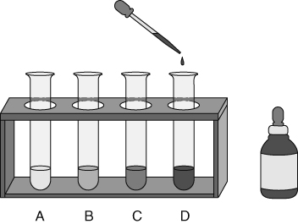

Recording your results
- Present your results in a table like the one below. Think carefully about how you order the elements in your table.
Oxide tested | Colour of indicator | pH of solution | acidic/alkali/neutral
Conclusions
- Write word equations for the formation of the oxides of calcium and phosphorus.
- How does the indicator colour tell you if a solution is acidic, alkaline or neutral?
- What are the ranges of pH values for
acids
- alkalis
- neutral solutions?
- Which pH values are:
most acidic
most alkaline?
- Describe any general trend in the chemical properties of the oxides across the periodic table from left to right.
- What conclusions can be made about the difference between the chemical properties of
metal oxides and non-metal oxides?
- Are there any results for type of solution and pH of the oxide that do not fit the trend?
Explain your answer.
- The oxides of chlorine and fluorine are difficult to produce. If they could be made, estimate the pH of solutions of these oxides, and explain your answer.
Evaluation
- What was easy and what was difficult about carrying out this investigation?
- Why is it difficult to draw any conclusion about the trend in pH of the oxides down a group, in the periodic table?
- What could you do to help you feel more certain of your conclusions?

I can...
- make and record observations accurately and draw conclusions
- use data to identify trends in chemical properties
- compare the chemical properties of metal and non-metal oxides.

