Describe the changes of state that occur to a substance at its:
melting point: changes to .
freezing point: changes to .
boiling point: changes to .
- Information about two elements X and Y is given in the tables below.
Element X |  |  | Element Y
Appearance | dull yellow solid |  | Appearance | shiny brown solid
Melting point (°C) | 113 |  | Melting point (°C) | 1083
Boiling point (°C) | 445 |  | Boiling point (°C) | 2567
Conduction of heat | poor |  | Conduction of heat | good
Conduction of electricity | does not conduct |  | Conduction of electricity | very good
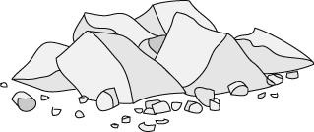 |  |  | 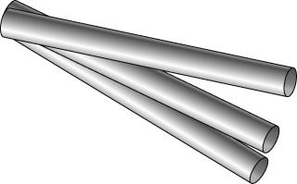
Is element X a metal or a non-metal? Explain your answer.

Is element Y a metal or a non-metal? Explain your answer.

Which element is most likely to be flexible and bend without breaking?

Which element would be most suitable for the bottoms of cooking pots? Explain your choice.

Give the state, solid (s), liquid (l) or gas (g) of the elements X and Y at the temperatures below.
100 °C | 300 °C | 500 °C | 3000 °C
X =  Y = | X =  Y = | X =  Y = | X =  Y =
I can...
- state what happens at a material’s melting, freezing and boiling points
- use information to predict the state of a substance at a given temperature
- identify metals and non-metals from their properties.

