

Look at the data in the charts below. It shows the melting points and boiling points of the
alkali metals in group 1.
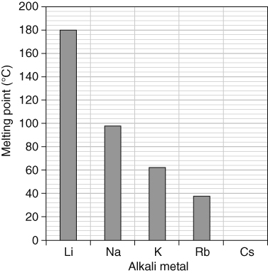 | 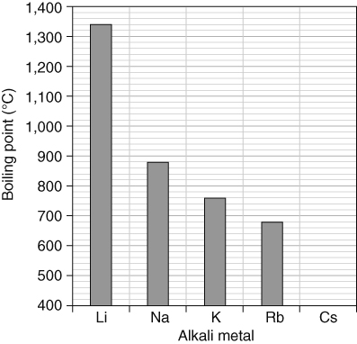
What is the general trend in melting points down group 1, the alkali metals?
Looking at the trend shown on the above bar chart, predict the melting point of the fifth alkali metal, caesium. Draw in the bar for caesium on the bar chart.
What is the general trend in boiling points down group 1, the alkali metals?
Looking at the trend shown on the above bar chart, predict the boiling point of the fifth alkali metal, caesium. Draw in the bar for caesium in the bar chart.
Use a data book or other source to find the actual melting point and boiling point for caesium. How close were your predicted values to the actual values.
Are there any melting points or boiling points of the alkali metals that do not follow the trend? Explain your answer.
- The tables below show data on the melting points of the halogens and noble gases.
Halogen | Melting point (°C) |  | Noble gas | Melting point (°C)
fluorine | –220 |  | helium | –272
chlorine | –101 |  | neon | –249
bromine | –7 |  | argon | –189
iodine | 114 |  | krypton | –157
Draw two separate bar charts to plot the melting points for
the halogens ii the noble gases
What are the ranges of the melting points for each group?
Describe the trend in melting points down each group.
Estimate the melting points of the fifth member of each group:
astatine in the halogens ii xenon in the noble gases.
How do your estimates compare with the actual values? (Use a data book to find out.)

I can...
- recall that there are trends in certain physical properties down groups in the periodic table
- use data to identify trends in physical properties within a group.

