
Cut out the graph below, and glue it in the middle of an A4 sheet of paper.

Temperature time graph

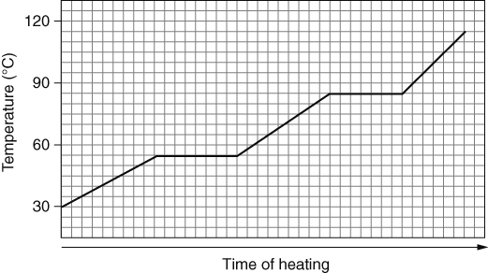
Your task is to explain what is happening at the different parts of the graph.
Cut out the cards below and glue them onto your sheet around the graph. Add lines to connect the correct place on the graph with each label.
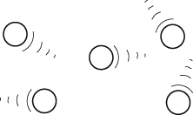 |  |  | 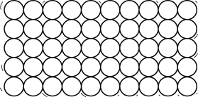 |  |  |  | 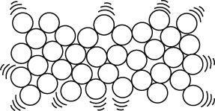
melting point | boiling point |  |  | liquid |  | solid |  |  | gas
energy being used to change state from solid to liquid |  | energy being used to change state from liquid to gas |  |  | energy being used to raise temperature of solid |  |  | energy being used to raise temperature of liquid
- If an element has a melting point of 44 °C and a boiling point of 280 °C, would it be a solid, liquid or gas if it were put in a place:
a at 100 °C?
b at 0 °C?
- Cut out the blank periodic table opposite and glue it onto a sheet of paper.  - Write in the headings, metals and non-metals above the table.  - Colour in the metals, non-metals and  semi-metals using different colours.  - Next to the metals, list their main properties.  - Next to the non-metals, list their main properties. | 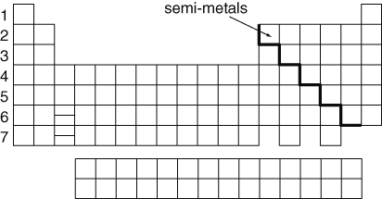
I can...
- state what happens at a material’s melting, freezing and boiling points
- use information to predict the state of a substance at a given temperature
- identify metals and non-metals from their properties and position in the periodic table.

