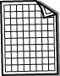
Place these things in order of increasing size.
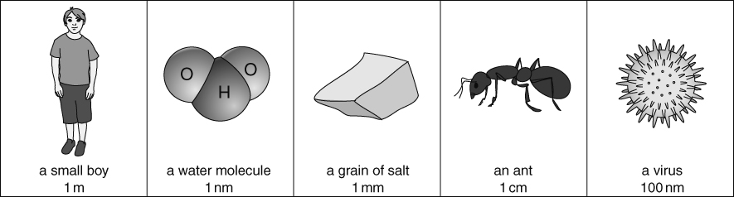
Length or size can be measured using different units. For example, metres, centimetres, millimetres or nanometres are all different units of length. The size of atoms is often measured in nanometres.
1 m = 100 cm 1 m =1000 mm 1 m = 1000 000 000 nm
How many nanometres are in 1 millimetre?
How many nanometres are in 1 centimetre?
A 1 pence coin measures 2 cm (0.02 m) across. Tin atoms have a diameter of 0.4 nm.
How many tin atoms can fit across a 1 pence coin?
- Diameter measurements of the atoms of common elements in the periodic table are given in the table below. All measurements are in nanometres.
Group 1 | Group 2 | Group 3 | Group 4 | Group 5 | Group 6 | Group 7 | Group 8
H (0.106) |  |  |  |  |  |  | He (0.062)
Li (0.334) | Be (0.224) | B (0.174) | C (0.134) | N (0.112) | O (0.096) | F (0.084) | Ne (0.076)
Na (0.380) | Mg ( ) | Al (0.236) | Si (0.222) | P (0.196) | S (0.176) | Cl (0.158) | Ar (0.142)
K (0.486) | Ca (0.368) | Ga (0.272) | Ge ( ) | As (0.228) | Se (0.206) | Br (0.288) | Kr (0.176)
Rb (0.530) | Sr (0.438) | In (0.302) | Sn (0.290) | Sb (0.266) | Te (0.246) | I (0.230) | Xe (0.216)
From the table, which element has the largest atoms and which element has the smallest atoms.
Describe the trend in atomic diameter down a group.
Describe the trend in atomic diameter across the periodic table, from left to right.
Using graph paper, draw a bar chart of the data on atomic size.
(The element name should go on the horizontal axis, in periodic table order.)
The data on atomic diameter for germanium and magnesium is missing from the table.
Estimate the size of the atoms of these two elements.
Explain how you were able to estimate the atomic size.
The graph is sometimes described as ‘periodic’ in nature. What do you think the word ‘periodic’ means as it is used to describe this graph? (Hint: Think about how and when periods occur in the menstrual cycle.)

I can...
- recall suitable units to measure particle diameters
- compare particle sizes to the sizes of common objects
- describe how the sizes of atoms change in the groups and periods of the periodic table.

