Your teacher may watch to see if you can:
- follow instructions and make observations carefully.
Aim
To identify trends across the periodic table in the physical properties of elements, including:
- appearance – state, colour, shiny or dull, etc.
- conduction of electricity – if placed in a circuit, does it allow electricity to pass through it?
- melting point – the temperature the solid starts to change into a liquid.
- density – a measure of mass per volume. Density (g/cm³) =$\frac{\text{Mass }(g)}{\text{Volume }({\text{cm}}^{3})}$
Prediction
Describe any trends you would expect to find in the physical properties of elements across the periodic table from left to right. Explain your reasoning for each of your predictions.
Draw up a suitable table to record the results of your investigations. (See ‘Recording your results’ on the following page.)
Method: Test 1 – Appearance
Apparatus  - samples of solid magnesium, aluminium, silicon and sulfur  - samples of the gases nitrogen and oxygen  - power supply  - bulb  - connecting wires  - access to the internet or data book |  Wash your hands after handling each sample.
- Look at each of the element samples.
- In your table, record the appearance of each element. Include the element’s state, colour, whether it is shiny or dull in appearance.
Method: Test 2 – Testing conduction of electricity
- Set up a circuit like the one opposite.  - Test the first element as shown. Does the bulb light up?  - Record the result in the table.  - Repeat the test with the other elements. | 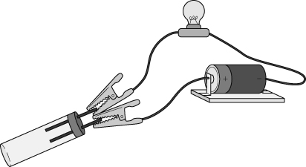
Method: Test 3 – Researching properties
- Find the densities and melting points of the elements used in Test 1.
- Record the information in your table.
Recording your results
Consider the data that you will collect in the three investigations outlined below. Draw up a suitable table to record this information. Think carefully about the order in which you place the elements in your table.
Considering your results/conclusions
- Describe the general properties of metals in terms of appearance, conduction of electricity, density and melting points.
- Describe the general properties of non-metals in terms of appearance, conductivity of electricity, density and melting points.
- Is there a trend in any of the properties below across the periodic table from left to right? Describe any trend there is.
appearance
- conduction of electricity
- density
- melting point
- For each property, identify any results which don’t fit the trend, and explain why they seem to be out of place.
appearance
- conduction of electricity
- density
- melting point
- Describe how properties change in elements across the periodic table from left to right.
Evaluation
- How could you improve this investigation into the trends in physical properties?
- The physical properties of elements can be used to define metals and non-metals. Which property or properties would be the best indicator to use when deciding if an element is a metal or a non-metal? Explain your answer.

I can...
- use data to identify trends in physical properties within a group
- identify metals and non-metals by their physical properties.

