

The diagram below shows the relative sizes of the atoms of the first 20 elements in the periodic table.
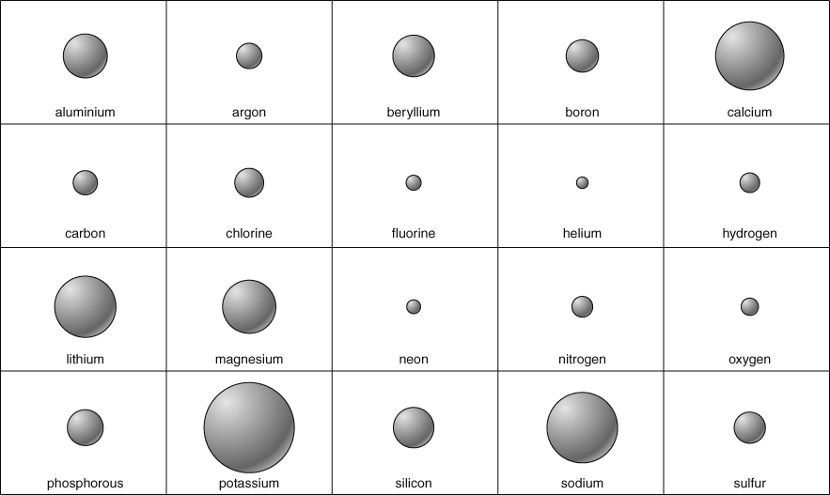
Cut out the atom diagrams and glue them in the same arrangement as in the periodic table.
- Look at your periodic table of atomic sizes for the first 20 elements.
Describe the general trend in atomic sizes across a period from left to right.
Describe the general trend in atomic sizes down a group from top to bottom.
Are there any results that don’t fit the trend? Explain your answer.
- Atoms are so small that they are measured in nanometres (nm).
1 nanometre = 0.000 000 001 metre so there are 1000 000 000 nm in 1 m.
To convert metres to nanometres multiply by 1000 000 000
To convert nanometres to metres divide by 1000 000 000
The diameter of an atom ranges from about 0.025 to 0.5 nanometres (nm).
How many hydrogen atoms, which measure 0.1 nm across, will fit across a single caesium atom with a diameter of 0.6 nm?
The diameter of a copper atom is approximately 0.3 nm. How many copper atoms could be lined up across a pin head measuring 1.5 mm (1 500 000 nm)?

I can...
- recall suitable units to measure particle diameters
- describe how the sizes of atoms change in the groups and periods of the periodic table.

