Look at the graph shown below, and then answer the questions which follow.
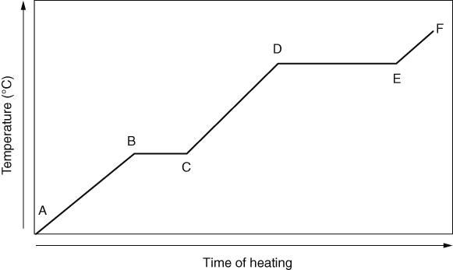
What is happening to the temperature in section E to F?
What is the state of the substance in section A to B?
What change of state is occurring in section D to E?
Explain why the temperature doesn’t rise in section B to C although heating continues.
- The melting points of elements in the periodic table are shown below.
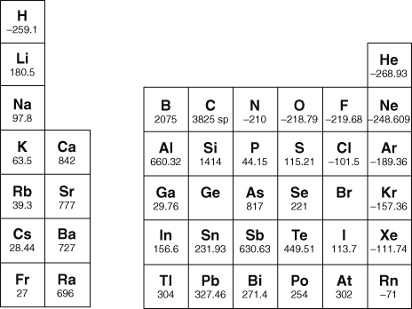
Name four elements in the halogen group.
Describe the general trend in melting points down the alkali metal and noble gas groups.
What is the general trend in melting points down group 6 from oxygen to polonium? Identify any melting point within this group that does not seem to fit the trend.
The melting points of germanium and bromine are missing. Estimate these melting points and explain your reasoning.

I can...
- recall that there are trends in certain physical properties down groups in the periodic table
- use data to identify trends in physical properties within a group.

