
Name Class Date
Arrange the jumbled letters to make a word that describes the change shown in the drawings.
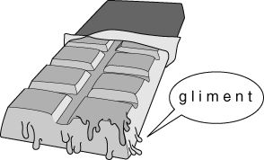 | 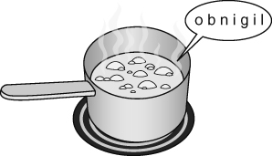 | 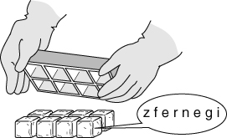
- Mark the melting points and boiling points for each substance on the temperature line below.
Colour in the temperature line to show where the substances are: solid (blue); liquid (green); and gas (red).
The first one has been marked for you (but not coloured).
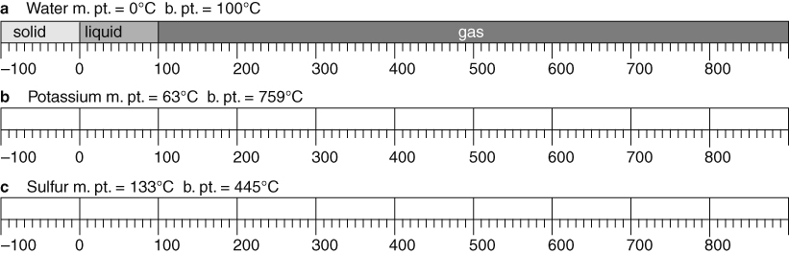
The periodic table opposite has the  semi-metals shaded in and labelled.  - Label and shade in the metals and  non-metals on the same table.  Colour key  - metals  - non-metals  semi-metals | 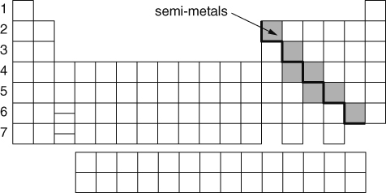
- Tick (✓) the correct boxes to show the typical properties of metals and non-metals.
 | Good conductors of electricity | Most are brittle when solid | Most have high melting points
Metals
Non-metals
I can...
- recall what happens at a material’s melting, freezing and boiling points
- use information to predict the state of a substance at a given temperature
- identify metals and non-metals from their properties and position in the periodic table.

