Name Class Date
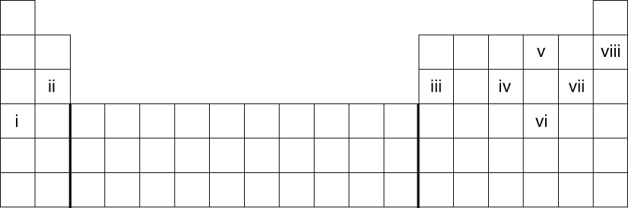
Which of the elements i to viii fit the following descriptions?
a An unreactive element. | b An alkali metal. | c Has the symbol P.
d Two similar elements.  and | e A halogen. | f A noble gas.
- Complete these sentences about some groups of elements in the periodic table.
Elements can be represented by international symbols like for carbon,
for calcium, for cobalt and for copper.
The group 7 elements are called the and include ,
and .
- For each of the following descriptions of elements, tick (✓) the correct column to show which group it belongs to.
Description | Noble gas | Halogen | Alkali metal
An unreactive element that does not form compounds easily
An element that reacts quickly with water, forming hydrogen gas
I can...
- identify the alkali metals, halogens and noble gases on the periodic table
- recall what elements in the same group have in common
- recall the main properties of noble gases.

