
Name Class Date
Use a copy of the complete periodic table to help you complete the questions below.
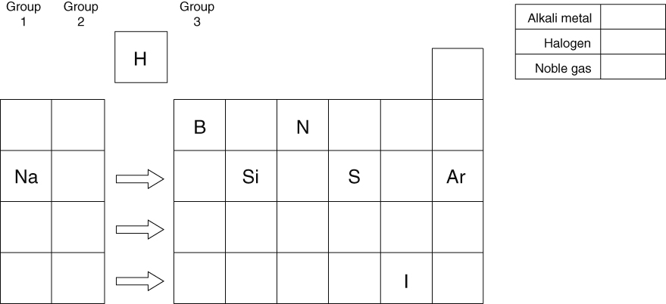
a Add the symbols for oxygen, aluminium and phosphorus in the correct places on the periodic table.
b Add the missing symbols for all the alkali metals. Colour the group in blue.
c Add all the missing symbols for the halogens. Colour the group in green.
d Add all the missing symbols for the noble gases. Colour the group in red.
e Add the symbols for two elements which will have some similar properties to silicon.
- Complete the crossword below using the clues given.
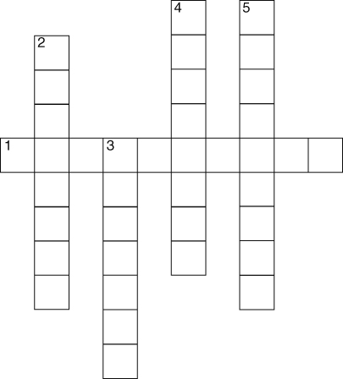 | Across  1 These elements are very unreactive  (5) and (5)  Down  2 A green gas that is a halogen (8)  3 The first alkali metal (7)  4 Group 7 elements are called this (8)  5 An element with similar properties to sodium (9)
I can...
- identify the alkali metals, halogens and noble gases on the periodic table
- describe the main properties of noble gases.

