Your teacher may watch to see if you can:
- work carefully and follow instructions to ensure as little smoke as possible is lost.
Introduction
When magnesium burns there is a bright flame and magnesium oxide is formed as a white ash/smoke. Usually much of the smoke rises into the air and is lost.
Aim
The aim of this experiment is to find the change in mass which occurs when a 10 cm piece of magnesium ribbon is completely burned to form magnesium oxide.
Prediction
How do you think the mass of magnesium oxide formed will compare to the original mass of magnesium burned?
Write down your prediction.
Explain your prediction.
Method
Apparatus  - Bunsen burner  - crucible and lid  - pipe-clay triangle  - heatproof mat  - tongs  - tripod  - electronic balance  - a strip of magnesium  (highly flammable)  - emery paper  - eye protection |  Wear eye protection.  Care needed when handling very hot crucible. | 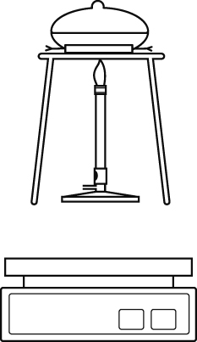
- Clean a piece of magnesium ribbon, approximately 10 cm long, with some emery paper.
- Loosely coil the ribbon and place it in the crucible. Put the lid on and weigh the crucible and its contents. Write down this mass.
- Put the crucible onto the pipe-clay triangle on the tripod, as shown in the diagram.
- Heat the crucible with a roaring blue Bunsen flame. Leave the lid off at the start.
- When the magnesium starts to burn, use the tongs to put the lid onto the crucible. This will stop the smoke escaping.
- About every 10 seconds, use the tongs to lift up the lid briefly to let some air in. Try not to let any smoke out.
- When you think that all the magnesium has burned, take the lid off and keep heating until you are sure that there are no more sparks or flames. Replace the lid if more smoke is given off.
When completely cool, measure the mass of the crucible with the ash in it. Don’t forget to put the lid on.

Recording your results
- Draw up a table to record your results.
Considering your results/conclusions
- a From your results, how did the mass of magnesium oxide formed compare to the original mass of magnesium? Did the mass increase or decrease?
b Was your prediction correct? Explain your answer.
- a What has the magnesium reacted with?
b What substance was formed?
- Write a word equation for the reaction.
- How does this equation help to explain your results?
- Note down the results of everyone in the class in a table.
- a Are there any anomalous readings? Explain your answer.
b What is the range of readings (omitting anomalous results)?
c Calculate the mean result for the whole class (omitting anomalous results).
Evaluation
- Can you be more certain that your conclusion is correct by using the mean class results rather than just your own results? Explain your answer.
- Suggest some reasons why different groups got different results.
Describe three possible sources of errors or reasons for obtaining anomalous results in this investigation.
- What should you do with any anomalous results when calculating the mean?
- Suggest how this experiment can be improved so that the results are more accurate.

I can...
- identify the range of readings in an experiment
- identify anomalous results/outliers in data
- suggest scientific reasons for anomalous results/outliers.

