One of the first steps towards producing a periodic table was in 1864 by the English chemist John Newlands. He knew that atoms of different elements had different masses. He had noted that if the elements were listed in order of increasing masses of their atoms, which he called ‘atomic weights’ (At. wt.), then certain properties recurred every eighth element. However, there were some obvious failings in his ideas and they were not widely accepted by other scientists at the time.
Two of Newlands’ sets of elements with recurring properties are shown below. They include his atomic weights and additional information about some of the elements.
hydrogen  At. wt. = 1 | fluorine  At. wt. = 8 | chlorine  At. wt. = 15 | cobalt/  nickel  At. wt. = 22  unreactive metal | bromine  At. wt. = 29 | palladium  At. wt. = 36  unreactive metal | iodine  At. wt. = 142 | platinum/ iridium  At. wt. = 50  unreactive metal
lithium  At. wt. = 2 | sodium  At. wt. = 9 | potassium  At. wt. = 16 | copper  At. wt. = 23  unreactive metal | rubidium  At. wt. = 30 | silver  At. wt. = 37  unreactive metal | caesium  At. wt. = 44 | osmium  At. wt. = 51  unreactive metal
Use a copy of the modern periodic table to help you answer the following questions.
a For the set of elements starting with hydrogen:
list four elements which fit into one of the main groups in the modern periodic table
name the group.
b For the set of elements starting with lithium:
name the elements which fit into one of the main groups in the modern periodic table
state the group name and number
explain in terms of properties why the ‘other’ elements don’t fit into this group.
- The first periodic table published by Dmitri Mendeleev in 1869 is shown opposite. He organised the elements in a similar way to Newlands. However, to make the pattern of properties fit better, he made a few changes to the order, and left gaps for unknown elements.  His table was not accepted at first. But in the years that followed, three new elements were discovered: scandium, gallium and germanium. Their properties were almost a perfect match for those predicted by Mendeleev, and so the periodic table became accepted by all chemists. | 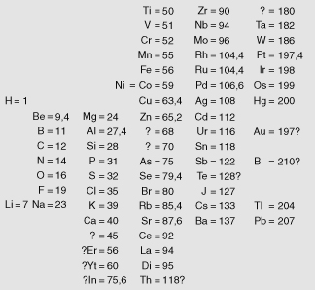
What do the numbers on Mendeleev’s table represent?
Why did Mendeleev put ‘?’ marks in place of the names of a few of the elements in his first table?
When gallium was discovered it was placed in between zinc and germanium in the periodic table. Eventually it ended up being put in the same group as boron and aluminium.
Why was gallium placed just after aluminium?
Explain how it was possible to predict gallium’s properties without testing the element.

I can...
- describe how Mendeleev arranged the elements in his periodic table
- describe the typical properties of some of the main groups of elements in the periodic table
- explain how Mendeleev made predictions using his table.

