Name Class Date
Circle the symbol that matches the following statements.
Statement | Symbol
This is the symbol for magnesium metal. | M | Ma | Mg
This element is a halogen. | Cl | He | Na
This element is a noble gas. | Ar | H | No
This element is an alkali metal. | Al | F | K
- Draw a line to match up the correct ends of each sentence.
Elements in the same group ... |  | ... the noble gases.
Fluorine gas has similar chemical properties to ... |  | ... an alkali metal.
Lithium metal is ... |  | ... have similar chemical properties.
The group of elements that are very unreactive is ... |  | ... bromine liquid.
- Look at the outline of the periodic table shown below.
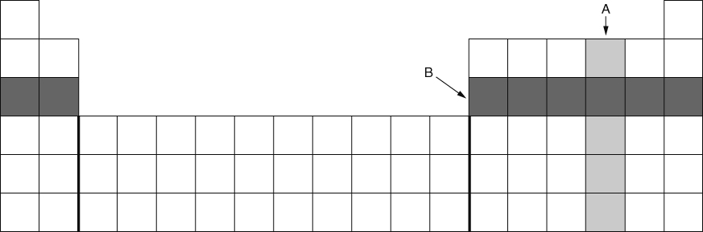
Which block, A or B, will contain elements with the most similar chemical properties? Explain your reasoning.

Name one property that is similar to the elements in this group.

I can...
- use the periodic table to find elements with similar properties
- describe the typical properties of alkali metals, halogens and noble gases.

