The valency of an element’s atoms is the number of bonds it has to make when it combines with other elements.  Cut out the element valency cards below and match them up to find the formulae of different compounds. Write out the names and formulae of the different compounds in a neat table. |   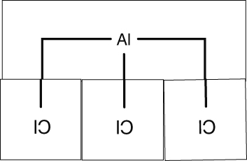
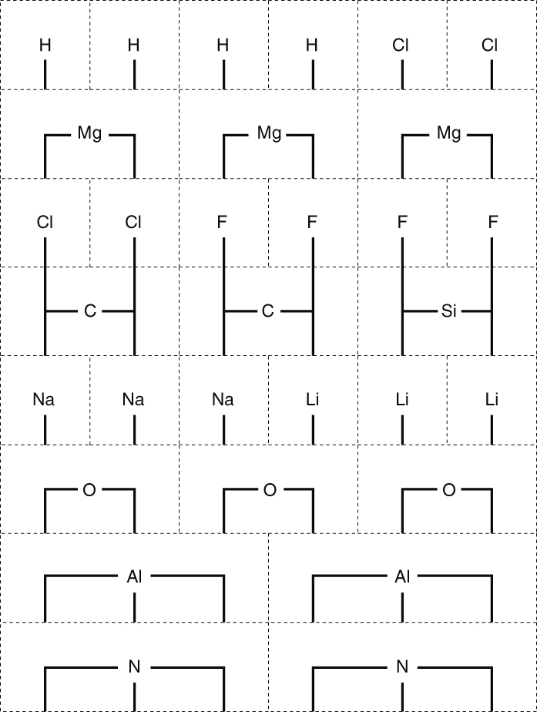

I can...
- write simple chemical formulae
- use valency to work out the formulae.

