Look at the diagrams below
i  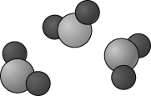 | ii  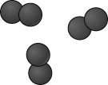 | iii  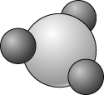
iv  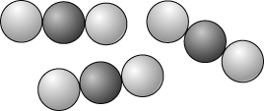 | v  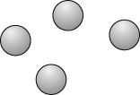 | vi  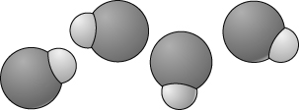
a Which of the substances are compounds?
b Explain you answer.
Which of the substances is phosphorus chloride (formula PCl₃) and which is hydrogen chloride (formula HCl)?
- Hydrogen atoms are smaller than any others.
Which diagram could represent water (formula H₂O)? Explain your reasoning.
- Heating substances can bring about physical and/or chemical changes. What makes a chemical change different from a physical change?
- Use ideas about atoms to explain why the mass of the products and reactants in a chemical reaction is always the same.
- 3.6 g of carbon reacts completely with 9.6 g of oxygen by the equation:
carbon + oxygen → carbon dioxide
What mass of carbon dioxide is formed?
- 6 g of calcium reacts with bromine and forms 30 g of calcium bromide.
What mass of bromine must have reacted?
Write out a word equation for this reaction.
- For a particular oxide of sulfur it was shown that the mass ratio sulfur : oxygen was 2 : 3. Therefore for every 2 g of sulfur you needed 3 g of oxygen to react with it.
What mass of oxygen would react with
10 g of sulfur?
24 g of sulfur?
- When the gas methane (CH₄) burns in oxygen (O₂) it forms the two compounds shown in boxes i and iv above.
Write a word equation to represent this reaction.
Explain what happens to the atoms in the molecules of the reactants during this chemical change.

I can...
- write simple chemical formulae from information on structure
- use particle diagrams to identify elements and compounds
- carry out simple calculations involving masses of reactants and products.

