Elements
The formula of most elements is just its symbol.
For example: carbon = C; magnesium = Mg, etc.
There are a group of elements, however, that exist as diatomic molecules (two atom molecules) and their formulae show this. For example, hydrogen = H₂; nitrogen = N₂; oxygen = O₂;
fluorine = F₂; chlorine = Cl₂; bromine = Br₂ and iodine = I₂ all exist as diatomic molecules.
Compounds
The positions of elements in the periodic table can be used to help us work out the formulae of their compounds. This works because the position of an element in the periodic table tells us the valency of the element. The valency is the number of bonds an atom of an element usually forms with other atoms. For example, all the elements in the first group (or column) of the periodic table have a valency of 1 and form one bond with other atoms. The table below shows the valency of some of the other main group elements. | 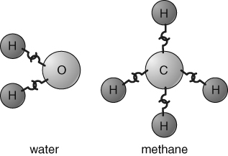  One way of visualising valency is to imagine that each atom has a number of hooks, which need to be linked up when they join together.

Group in periodic table | 1 | 2 | 3 | 4 | 5 | 6 | 7
Valency | 1 | 2 | 3 | 4 | 3 | 2 | 1
Examples | H  Li  Na | Be  Mg  Ca | B  Al | C  Si | N  P | O  S | F  Cl
The easiest way of working out a formula is to use the cross-over method.
This involves the following steps:  Write the symbols of the elements.  Write the valencies of the elements below the symbols.  Cancel down or simplify the valencies if possible.  Cross-over the numbers and tidy up to give the formula.  Some examples are shown opposite. | Example 1 1. symbols Al O  aluminium oxide 4. cross-over  2. valency 3 2  Formula Al₂O₃
Example 2 1. symbols Si O
silicon dioxide 4. cross-over
2. valency 4 2 2 1 3. cancel
Formula SiO₂
Try the following examples:
calcium sulfide  lithium nitride  magnesium fluoride | carbon chloride  phosphorus hydride  lithium phosphide | sodium sulfide  calcium oxide  carbon oxide | boron phosphide  aluminium nitride  silicon carbide
I can...
- work out a simple chemical formula using valency.

