Name Class Date
Explain the difference between a chemical change and physical change.

The pictures below show some changes that might happen in a jeweller’s workshop.
Look at the drawings and circle the correct change, physical or chemical, for each one.
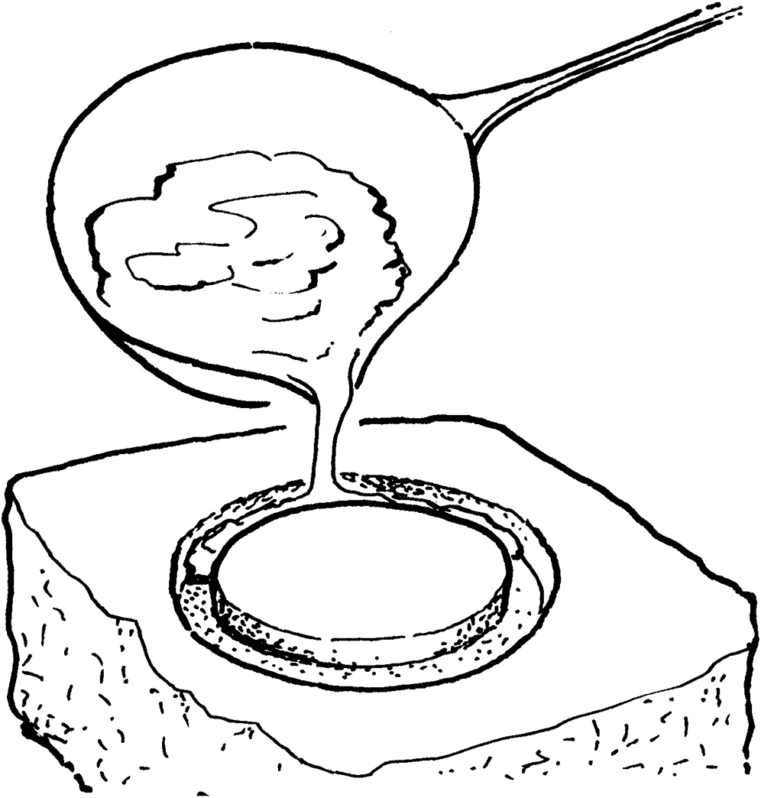  Molten silver turning into a solid.  physical or chemical | 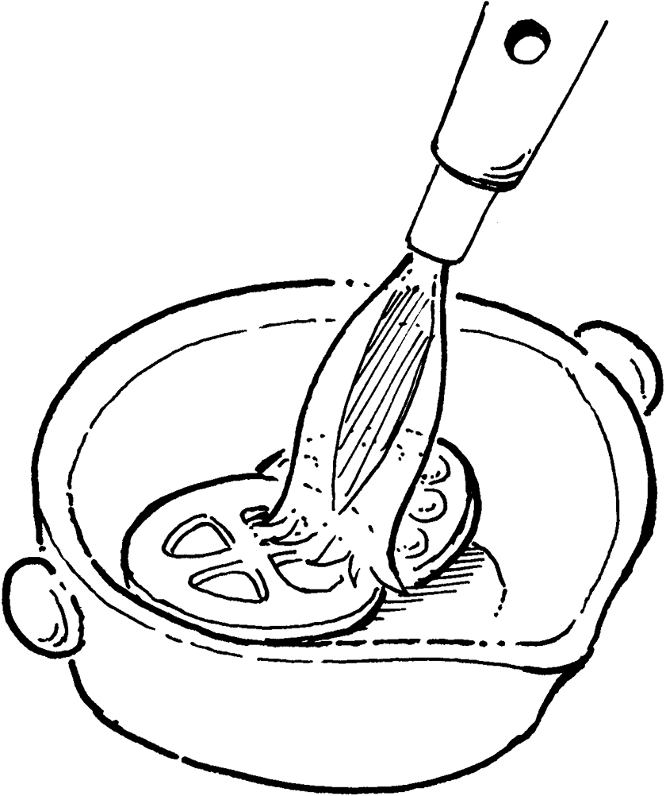  Propane gas burning to melt gold.  physical or chemical | 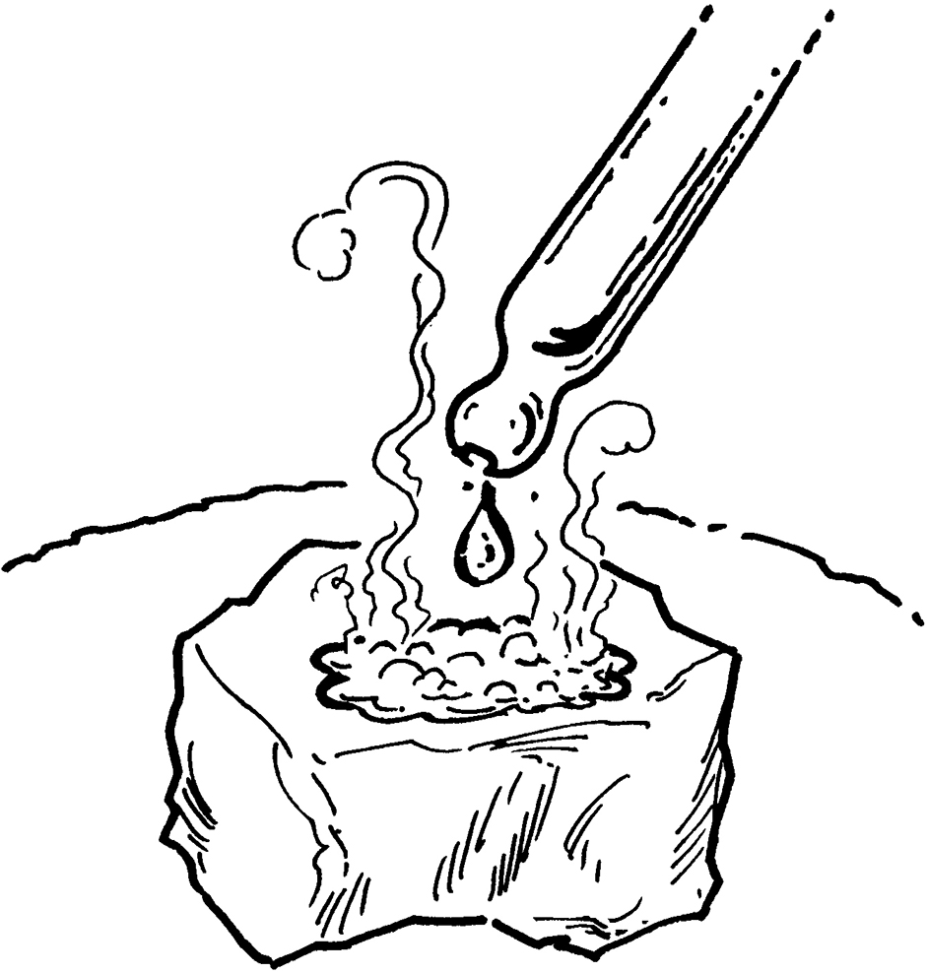  Testing stones with acid to see if they are marble.  physical or chemical
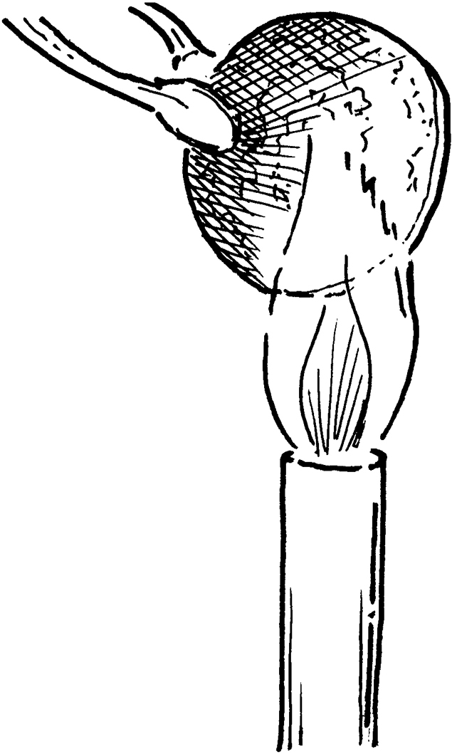  Metal coin being heated and  turning black. This is used as a  test for the metal.  physical or chemical | 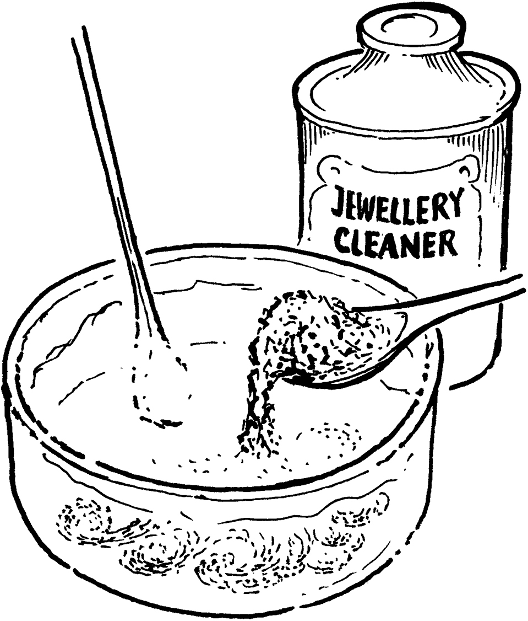  A solid is dissolved to make a solution used to clean jewellery.  physical or chemical | 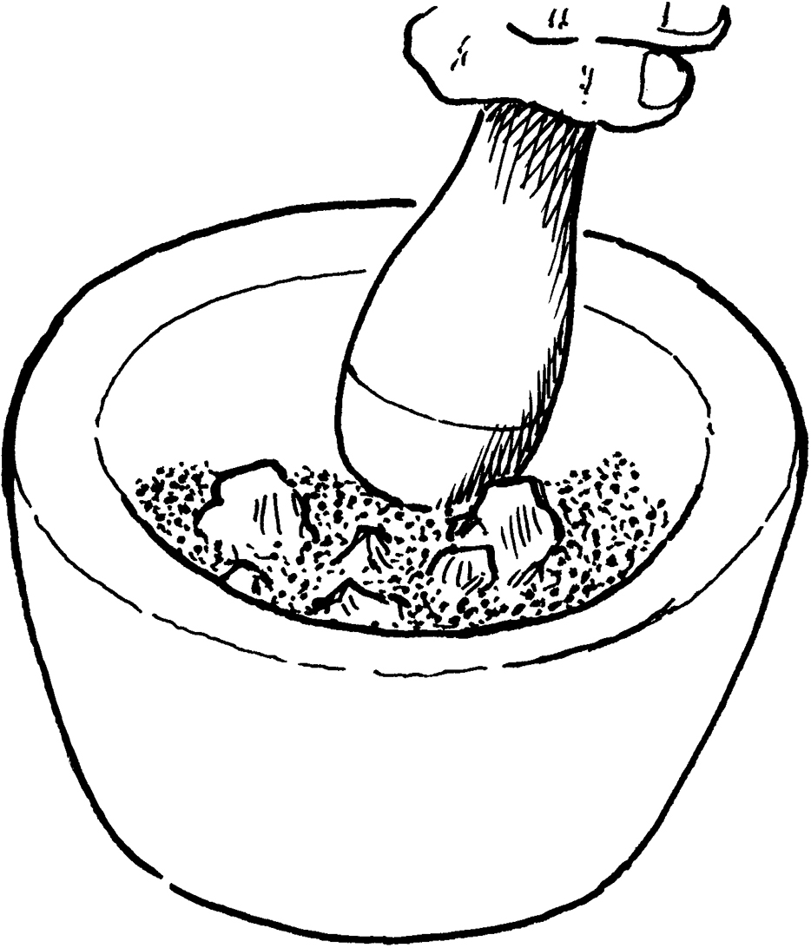  The solid must be turned into a powder to be used in polishing gemstones.  physical or chemical
- Describe a chemical reaction that happens in the home or outside which:
gives out heat to the surroundings

involves a change of colour.

- When carbon burns it combines with oxygen to form the compound carbon dioxide.
Write a word equation for this reaction.
 .
- The box below contains descriptions of possible properties of a substance.
Circle the words and phrases that describe chemical properties.
strength flammability colour flexibility reaction with water
conduction of heat pH

I can...
- identify and explain the difference between chemical and physical changes and properties.

