Name Class Date
Rearrange the letters of the words in the brackets to complete these sentences about John Dalton’s atomic theory.
(s o u n d c o m p) contain atoms of different elements joined together.
During chemical reactions atoms are rearranged, to make (w e n) substances.
- Draw lines to complete the sentences.
 | In chemical changes … |  | … no new substances are formed.
 | In a physical change … |  | … are examples of physical changes.
 | Changes of state … |  | … a new substance is always formed.
- The ratio of hydrogen to fluorine in hydrogen fluoride is  1 : 1.  The ratio of carbon to sulfur in carbon sulfide is  : . |  |  |  | 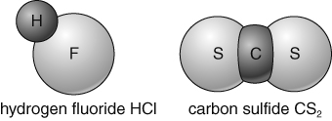
- Tick (✓) the correct box to say if the property described is a physical or chemical property.
The first one has been done for you.
Description of property | Chemical property | Physical property
Flammability (how easily something catches fire) | ✓
Melting point and boiling point
Conduction of electricity
pH of solution
- Write the formula for the compounds whose molecules are shown below.
a  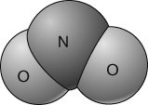 | b  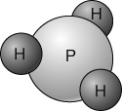
I can...
- explain the difference between physical and chemical changes and properties
- use atomic theory to explain what happens during chemical reactions
- write and interpret chemical formulae for compounds.

