Name Class Date
Your teacher may watch to see if you can:
- follow instructions to construct circuits ● read a digital measuring instrument.
Build each circuit, and answer the questions.
A Bright bulbs
The bulb is  .  (bright/dim). | 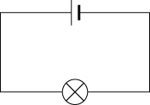 | The bulb is  .  (brighter than/the same as/dimmer than) before. | 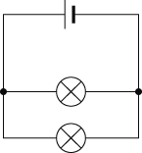
When I add bulbs in parallel the bulbs (stay bright/get dimmer).
In a series circuit, the bulbs get (brighter/dimmer) when more are added.

B Missing bulbs
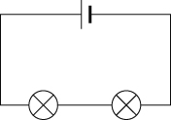
This is a series circuit. If I take out one bulb, it leaves a gap in the circuit. The other bulb  (goes off/stays on). | This is a parallel circuit. If I take out one bulb, the other bulb .  (goes off/stays on). There is still a complete circuit for the current to flow around through the other bulb.

C Current
1  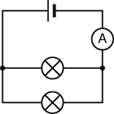 | 2  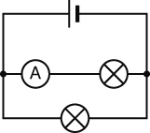 | 3  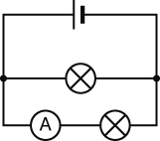
current = amps | current = amps | current = amps
current (2) + current (3) = amps
The current in the main part of the circuit is (the same as/much bigger than/much smaller than) the current in the two branches added together.
I can…
- describe how changing the number of bulbs in a circuit affects the current
- measure the current in part of a circuit using an ammeter
- describe how the current in a parallel circuit divides
- draw a conclusion from evidence.

