Name Class Date

Read the following passage and then answer the questions that follow.
Under the right conditions metals like sodium, aluminium and calcium can burn in oxygen forming the metal oxide. Magnesium metal burns brightly in oxygen gas to form white clouds of solid magnesium oxide. During the reaction the magnesium and oxygen atoms join together to form a new substance.
We can model this chemical reaction by drawing diagrams of the atoms and molecules of reactants and product or using a simple word equation.
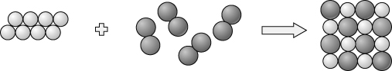
Word equation: magnesium + oxygen → magnesium oxide
What is all matter made up of?
- Oxygen exists as molecules. What is a molecule?
- Describe sodium, aluminium and calcium by three of their common physical properties.

- What do all the particles in a particular element have in common?

- How did Dalton describe a compound?

- Calcium reacts with oxygen in a similar way to magnesium. Write a word equation for this reaction.

- Match the following elements to their international symbol.
aluminium ; carbon ; calcium ; sodium .
C Ca Na Al
- The modern symbols for some elements are just the first letter of the element’s name.
The following elements follow this pattern. What are their symbols?
oxygen | fluorine | hydrogen | iodine
- Some elements have symbols that use the first two letters of their names. The following elements follow this pattern. What are their symbols?
silicon | argon | neon | calcium

I can...
- describe John Dalton’s ideas about molecules, atoms and matter
- use ideas about atoms to describe the difference between elements and compounds
- write simple word equations.

