
John Dalton thought that all the atoms in a particular element were identical but that atoms of different elements were different. This meant that all the atoms of a certain element have the same mass but that atoms of different elements have different masses. Hydrogen atoms were given a mass of ‘1’ and the other elements were compared to this. We say that the masses of the atoms are all relative to hydrogen, and so we call these relative atomic masses.
The modern relative atomic masses for some common elements is given below.
Element | Al | Ca | C | Cu | H | Fe | N | O | Si | S
Relative atomic mass | 27 | 40 | 12 | 64 | 1 | 56 | 14 | 16 | 28 | 32
Draw a bar chart of this data, using the names of the elements, in alphabetical order.
(Use a different colour for each element.)
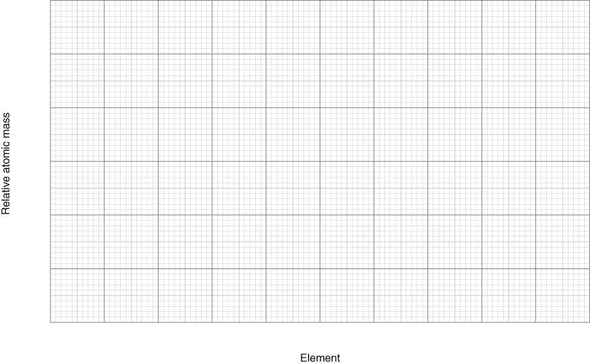
- Which of these elements have the heaviest atoms?
- How many hydrogen atoms would have the same mass as one calcium atom?
- Which element has atoms that are:
twice the mass of oxygen atoms?
half the mass of silicon atoms?
- If copper and sulfur atoms combine in a ratio of 1 : 1 then 64 g of copper combines with
32 g of sulfur. What mass of sulfur will combine with 2 g of copper?
- If calcium and oxygen atoms combine in a ratio of 1 : 1, what mass of oxygen combines with:
40 g of calcium
10 g of calcium?

I can...
- state what is meant by relative atomic mass.

