
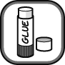
Colour in the atoms in the diagrams below. Use the same colour for atoms of the same element.
Add in the correct word to complete the sentences about atoms, elements and compounds.

Cut out and match the diagrams and sentences below in pairs to make a poster. The title of the poster should be Dalton’s atomic theory.

All matter is made up of tiny particles called . | Atoms cannot be . or destroyed. |  | All the atoms in an element are the .
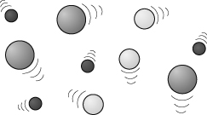 | 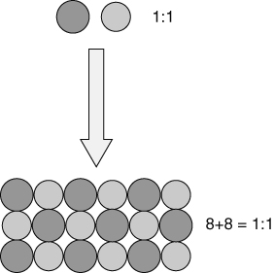 |  | 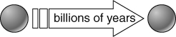
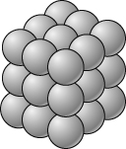 |  |  | 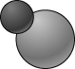
In compounds, each atom of an element is always joined to a fixed of atoms of other elements. |  | A compound contains atoms of .  elements joined together.
- Rearrange the letters to make the names of two elements found in fireworks. Write the chemical symbol next to each name.
no crab  name symbol . | spout aims  name symbol .
- Write the word equation for the reactions described below:
The reaction between iron metal and oxygen gas making solid iron oxide.
Silver metal reacting slowly with a gas in the air to form black silver oxide.
Tin reacting with chlorine gas forming a single green solid tin compound.

I can...
- describe John Dalton’s atomic theory
- write and identify the chemical symbols for elements
- write simple word equations.

