Name Class Date
- Rearrange the letters to complete these sentences about John Dalton’s atomic theory.
In a each atom of an element is always joined to a fixed number of atoms of other elements.
d o c o p n u m
Everything is made up of tiny particles called .
m o a t s
Atoms are indestructible, and cannot be created, or .
s o r t e d d y e
The atoms in an are all identical (but each has its own type of atoms).
t e e n e l m
During chemical reactions atoms are rearranged, to make substances.
w e n
- The particle diagrams for two different substances are shown below.
Circle the two words in each box that fit the particle diagrams.
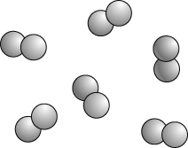  atoms / molecules / element / compound | 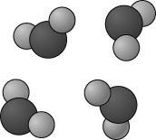  atoms / molecules / element / compound
- Circle the words or phrases in the box below which could be used to describe the
physical properties of the copper metal used for water pipes and electrical wires.
brown colour reacts with air high melting point good conductor of heat
strong silver coloured
- Complete the table below by adding the missing elements names or modern symbols.
Element name | Symbol | Element name | Symbol
carbon | O | chlorine | N
I can...
- describe Dalton’s atomic theory
- write and identify the chemical symbols for elements
- describe elements using physical properties.

