Each renewable energy resource has its advantages and disadvantages. Sometimes more than one resource is needed. For instance, you can only use wind turbines when the weather is windy, but sometimes the wind is too strong and the turbine has to be stopped. You would need another energy resource to use on calm days or on very windy days.
The people below want to use some renewable energy resources. They will still buy electricity, but if they can have one or two renewable energy resources their electricity bills will be lower.
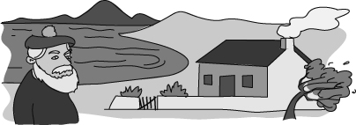 | 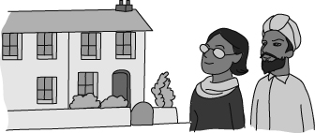
Mr McCloud lives in a small cottage on an island off the coast of Scotland. He lives near the sea, in a sheltered bay where the water is usually calm. He has built a wall around his garden to protect his plants from any strong winds. | Mr and Mrs Singh live in a village in Hampshire, in the south of England. They like living there because the weather is warm.
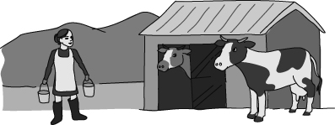 | 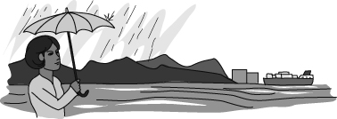
Mrs Williams runs a farm in Wales. She keeps lots of cows, which live indoors during the winter because the weather is very cold. | Mrs Jensen owns an aluminium factory. It is built at the end of a sea loch in Scotland so that ships carrying the raw materials can reach the factory. There are high hills just behind the factory. She can spend a lot of money on her renewable energy resource, because it will save her a lot of money in the long run.
- Decide which renewable energy resource each person should use, and explain why you have chosen that one. Some people might need more than one resource, but no one can have more than two.
- Choose one of the people and write a letter to them explaining why they should choose a particular renewable energy resource.
I can…
- decide and explain the best energy resources to use in an area.

