Aim
To find out if thermal decomposition happens in the same way for all metal carbonates.
Introduction
When calcium carbonate is heated it can break down into solid calcium oxide and carbon dioxide gas.
calcium carbonate  calcium oxide + carbon dioxide
Prediction
- Do you think that all the metal carbonates will break down in a similar way?
Method
 | Apparatus  - eye protection • copper carbonate powder  - Bunsen burner • potassium carbonate powder  - heat-resistant mat • magnesium carbonate powder  - clamp and stand • calcium carbonate powder  - test tubes • limewater  - delivery tube |  |  Make sure that you wear eye protection for all these experiments.  Be careful to remove the tube from the limewater when you stop heating to avoid suck-back.  Remove the limewater BEFORE removing the heat.
- Set up the apparatus as shown using one of the metal carbonates.  - Heat the test tube of carbonate gently at first, slowly increasing the heat.  - Stop when the limewater turns milky and note how hard you had to heat the carbonate. Remove the limewater BEFORE removing the heat.  - Repeat with fresh limewater and a different metal carbonate. |  | 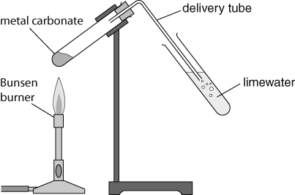
Recording your results
- Record your results in a suitable format. Note the substances used and your observations of how easily the carbonates broke down.
Considering your results/conclusions
- Which carbonate decomposed most easily and which was hardest to break down.
- Write word equations for the decomposition reactions that occurred.
- What product was common to all reactions?
- Was your prediction correct? In what ways was it correct and in what ways was it incorrect?
Evaluation
- What could you do to improve your investigation?
I can...
- describe what happens in metal carbonate decomposition reactions
- make and record observations accurately and draw conclusions.

