
Name Class Date
Under the right conditions silver-coloured aluminium metal powder can react violently with the purple non-metal called iodine.  The reaction gives out heat and light as the elements form a compound.  The properties of the compound are very different from the elements it is formed from. | 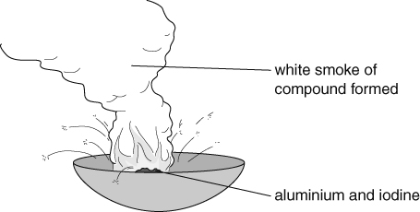
- Explain the difference between an element and a compound.
- How could you get the mixture of aluminium and iodine to start reacting?
- How is a mixture of iodine and aluminium different from the compound?
- Name the compound formed between iodine and aluminium.
- Suggest two other ways that a compound might be different from each of the elements of which it is formed.
- The compound formed by this reaction exists as molecules. Each molecule contains one atom of aluminium and three atoms of iodine. The aluminium atoms are only bonded to iodine atoms. The iodine atoms are only bonded to aluminium atoms.
- Use this information to draw three molecules of the compound in the box below.
- Colour the atoms in the diagram. Use the colour grey for aluminium and purple for iodine.
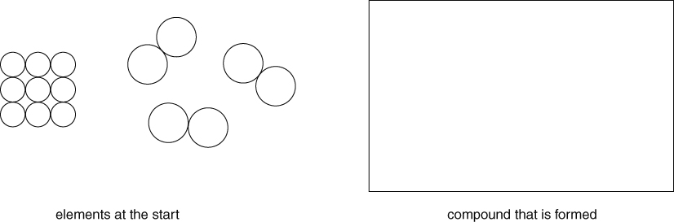
- Compounds are sometimes represented by the symbols of the elements joined together.
Name the compounds shown below
- NaCl | - MgO
- ZnS | - AgBr
I can...
- describe the changes you might see when compounds are formed
- identify elements, mixtures and compounds from particle diagrams
- name simple compounds.

